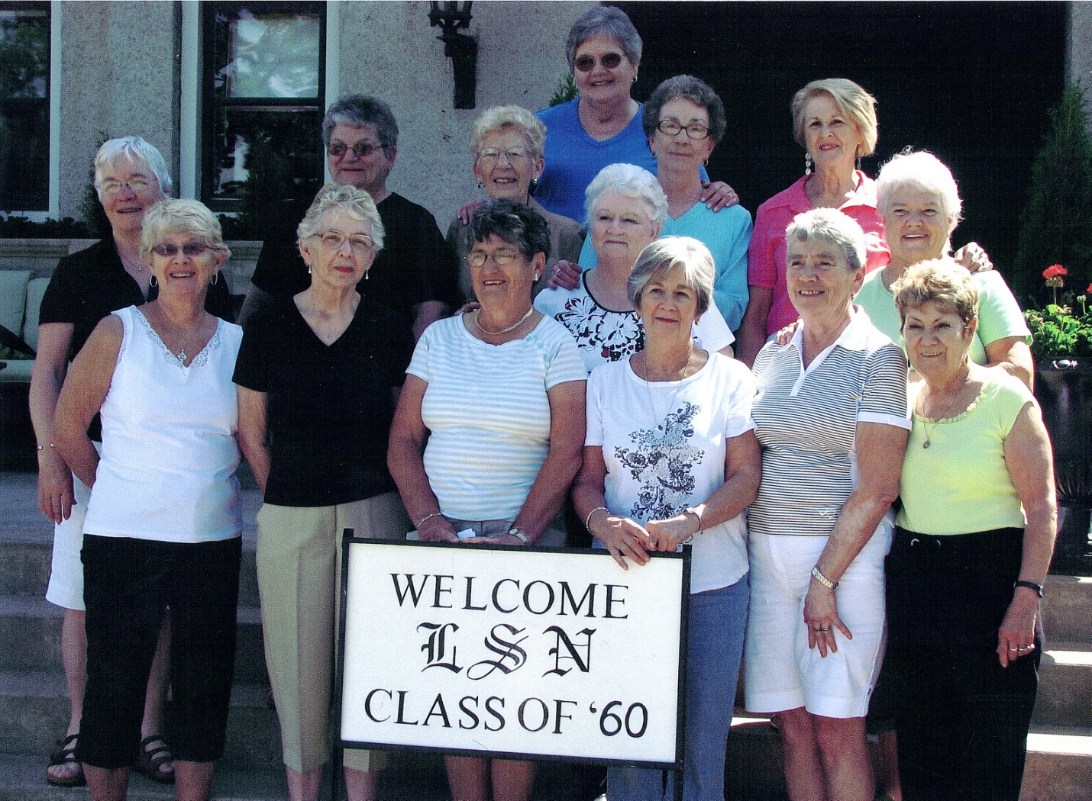

FR-Joy (Gillisie) Fontaine, Bertha (Lemire) Jones, Judy (Ross) Macdonald, Carol (Cuthbert) Myles, Kay (Wren) Knott, Collette (Demers) Beaupre.
MR – Mona (Fitxpatrick) McInnis, Gisele (Gervais) Shields, Helen (Kenopic) Emery, Doreen ( Dollighan) Peever, Joy(McGregor) Quattrochi, Carol (Platt) Baxter, Paula (Poirier) McCormick.
Back- Margaret Ann (Thompson) Kreiger.

